State transition testing

NAPD_Contract => protected void stealAgenda(Corporation corp, Runner runner, String accessedServer)

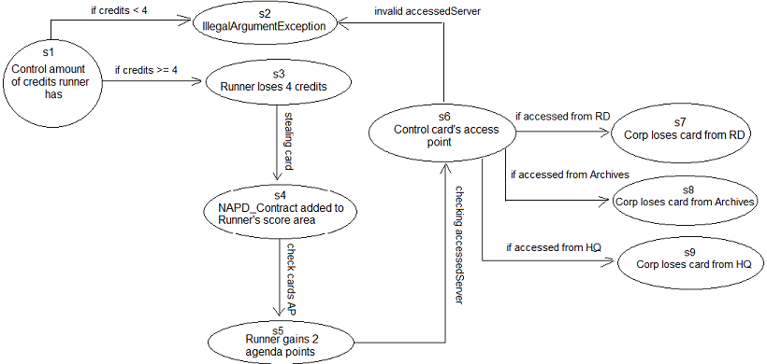

|  |  |  |  |
| --- | --- | --- | --- |
| ID | Beskrivning | Täckta tillstånd | Täckta övergångar |
| 1 | 1. Credits are less than 4 | s1, s2 | “if credits < 4” |
| 2 | 1. Credits are bigger than or equal to 4  2. Runner steals corp card  3. Control corp's agendaPoints  4. Check String accessedServer input  5. Stolen from RD  6. Stolen from Archives  7. Stolen from HQ | s1, s3  s4  s5  s6  s7  s8  s9 | “if credits >= 4”  “stealing card”  “check card's AP”  “checking accessedServer”  “if accessed from RD”  “if accessed from Archives”  “if accessed from HQ” |
| 3 | 1. Check String accessedServer input | s2 | “invalid accessedServer” |